XTRX rev5 Gerber files definitions:
Paste TOP – XTRXr5.GTP
Silk TOP – XTRXr5.GTO
Mask TOP – XTRXr5.GTS
L1: TOP Layer – XTRXr5.GTL
L2: 1st internal – XTRXr5.GP1 (Negative Plain)
L3: 2nd internal – XTRXr5.G1
L4: 3rd internal – XTRXr5.G2
L5: 4th internal – XTRXr5.GP2 (Negative Plain)
L6: 5th internal – XTRXr5.G3
L7: 6th internal – XTRXr5.GP3 (Negative Plain)
L8: BOTTOM Layer – XTRXr5.GBL
Mask BOTTOM – XTRXr5.GBS
Paste BOTTOM – XTRXr5.GBP
Boarder – XTRXr5.GKO
NC drill plated – XTRXr5-Plated.TXT (Through holes, 7.8 mil, 0.3 mm and 2.6 mm diameters)
NC drill plated GTL / GP1 / G1 – XTRXr5-Plated.TX1 (Two deep microvias or cap covered drilled vias, diameter 7.8 mil)
NC drill plated GBL / GP3 / G3 – XTRXr5-Plated.TX2 (Two deep microvias or cap covered drilled vias, diameter 7.8 mil)
Assembly/Mechanical TOP – XTRXr5.GM1
Assembly/Mechanical BOTTOM – XTRXr5.GM2
Physical PCB structure (EXAMPLE):
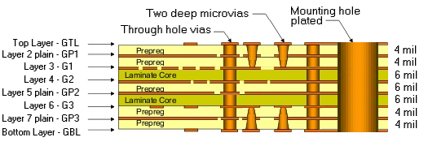
Overall Size – 50.8 x 29.7 mm ± 0.25 mm, thickness without solder mask (edge connector) – 1 mm ± 0.1 mm.
Finishing – gold plating over minimum of 150 micro-inches of nickel, with a minimum thickness of 30 micro-inches of hard acid gold for edge connector finger tabs and minimum of 4 micro-inches of immersion gold for entire board.
Facets – 45° x 0.25 mm (maximum) for edge connector.
Important:
– keep 50 Ohm impedance on GTL and GBL layers for 6 mil lines and on G1 and G3 layers for 4 mil lines.
– keep stable mask and silkscreen thickness for more stable fit of stencil and accurate dosing of soldering paste.

